**IRIMASO MAURICE ASSIGNMENT 2**

**Describe the steps to download and install Visual Studio Code on Windows 11 operating system. Include any prerequisites that might be needed.**

### **Steps to Download and Install Visual Studio Code on Windows 11:**

#### **Step 1: Visit the Official Website**

1. **Visit the Visual Studio Code website**: Go to [code.visualstudio.com](https://code.visualstudio.com/).

#### **Step 2: Download the Installer**

1. **Download the Installer**: Click on the "Download for Windows" button. The website should automatically detect your OS.

#### **Step 3: Run the Installer**

1. **Locate the Downloaded File**: Navigate to your Downloads folder or the location where the installer was saved.
2. **Run the Installer**: Double-click on the downloaded installer file (VSCodeSetup-x64-<version>.exe) to start the installation process.

#### **Step 4: Confirm User Account Control**

1. **Confirm User Account Control**: If prompted by User Account Control, click "Yes" to allow the installer to make changes to your device.

#### **Step 5: Select Installation Options**

1. **Choose Setup Type**: Select whether to install VS Code just for the current user or for all users of the computer.
2. **Choose Additional Tasks**: Optionally, select additional tasks like adding VS Code to the PATH variable or creating desktop icons.

#### **Step 6: Install Visual Studio Code**

1. **Install**: Click the "Next" button to proceed with the installation.
2. **Wait for Installation**: Wait for the installer to complete the installation process. This may take a few moments.

#### **Step 7: Launch Visual Studio Code**

1. **Launch**: Once the installation is complete, click "Finish" to exit the installer and launch Visual Studio Code.

#### **Step 8: Verify Installation**

1. **Check Version**: Open VS Code and check the version by going to Help > About Visual Studio Code.

### **Optional Step: Install Extensions**

1. **Install Extensions**: Explore and install extensions from the Extensions view (Ctrl+Shift+X) in VS Code to enhance functionality for coding, debugging, and more.

By following these steps, you can successfully download, install, and set up Visual Studio Code on your Windows 11 operating system.

**After installing VS Code, what initial configurations and settings should be adjusted for an optimal coding environment? Mention any important settings or extensions.**

#### **1. User Interface Customization:**

* **Theme**: Choose a color theme (e.g., Dark+ or Light+) from File > Preferences > Color Theme.
* **Icons**: Install an icon theme for better visual organization (Ctrl+Shift+X to open Extensions view).

#### **2. Font and Text Editor Settings:**

* **Font**: Set a preferred font and size under File > Preferences > Settings > Text Editor > Font.
* **Line Numbers**: Toggle line numbers visibility (Ctrl+Shift+P and search for "Toggle Line Numbers").

#### **3. Editor Enhancements:**

* **Auto Save**: Set auto-save preferences (File > Auto Save or Ctrl+Comma and search for "Auto Save").
* **Tab Size**: Adjust tab size and indentation (File > Preferences > Settings > Editor: Tab Size).

#### **4. Extensions for Productivity:**

* **ESLint/Pylint**: Install linters for real-time code analysis (Ctrl+Shift+X and search for ESLint or Pylint).
* **GitLens**: Enhance Git integration with features like blame annotations (Ctrl+Shift+X and search for "GitLens").

#### **5. Integrated Terminal:**

* **Shell Selection**: Choose your preferred shell (e.g., PowerShell, Command Prompt, Git Bash) in the integrated terminal.

#### **6. Version Control Integration:**

* **Git Configuration**: Set up Git integration and configure your name and email (Ctrl+Shift+P and search for "Git: Configure Global User Name" and "Git: Configure Global User Email").

#### **7. Settings Sync (Optional):**

* **Sync Settings**: Use the "Settings Sync" extension to synchronize your settings and extensions across different machines.

### **Additional Tips:**

* **Explore Extensions**: Continuously explore and install extensions (Ctrl+Shift+X) that enhance your workflow for specific languages, frameworks, or tools.
* **Keyboard Shortcuts**: Familiarize yourself with useful keyboard shortcuts (Ctrl+K Ctrl+S to view and customize shortcuts).

By adjusting these initial configurations and settings, you can tailor Visual Studio Code to your preferences and optimize your coding environment for efficiency and productivity. Adjustments may vary based on your coding preferences and specific project requirements.

**Explain the main components of the VS Code user interface. Identify and describe the purpose of the Activity Bar, Side Bar, Editor Group, and Status Bar.**

### **1. Activity Bar:**

* **Purpose**: The Activity Bar is located on the side of the window (usually on the left) and provides quick access to different views and panels within VS Code.
* **Components**: It includes icons for various activities such as Explorer (file explorer), Search (global search), Source Control (Git integration), Run and Debug (debugging tools), and Extensions (manage installed extensions).
* **Usage**: Users can switch between these activities by clicking on the respective icons, facilitating seamless navigation and workflow management.

### **2. Side Bar:**

* **Purpose**: The Side Bar is adjacent to the Activity Bar and contains additional panels and views that provide context-specific information and tools.
* **Components**: It typically includes panels like Explorer (file explorer for navigating project files), Search (for finding text across files), Git (for managing version control operations), Extensions (managing installed extensions), and more.
* **Usage**: Users can expand or collapse panels within the Side Bar based on their current task, allowing easy access to project files, search results, Git changes, and installed extensions.

### **3. Editor Group:**

* **Purpose**: The Editor Group is the central area where files and code are edited.
* **Components**: It consists of one or more editors (tabs) where individual files or documents are opened and edited simultaneously.
* **Usage**: Users can navigate between open files by clicking on their respective tabs or using keyboard shortcuts (Ctrl+Tab to cycle through open editors).

### **4. Status Bar:**

* **Purpose**: Located at the bottom of the VS Code window, the Status Bar provides information about the current state of the editor and project.
* **Components**: It displays information such as the current branch in Git, line and column numbers of the cursor position, language mode (e.g., JavaScript, Python), and notifications (e.g., errors or warnings).
* **Usage**: Users can interact with elements in the Status Bar, such as clicking on the language mode to change it or clicking on Git information to perform Git operations (e.g., commit, pull).

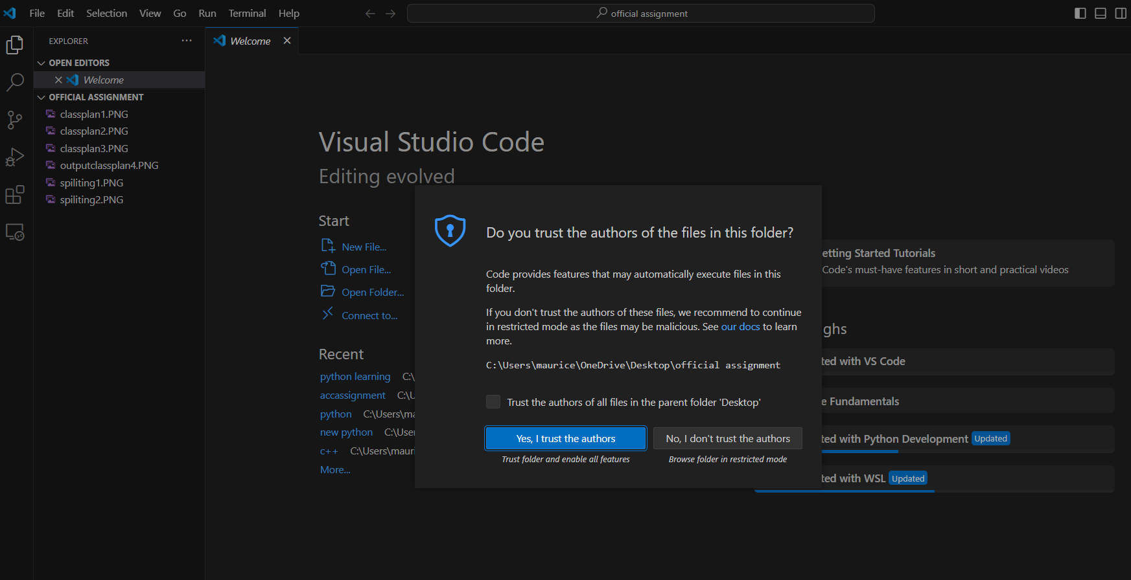

### **Accessing the Command Palette:**

To access the Command Palette in VS Code, you can use the following methods:

1. **Keyboard Shortcut**: Press Ctrl+Shift+P (Windows/Linux) or Cmd+Shift+P (Mac).
2. **Menu Option**: Click on View in the top menu, then select Command Palette.

### **Examples of Common Tasks using the Command Palette:**

1. **File and Workspace Operations**:
   * Open a file: Type "File: Open File" and enter the file path.
   * Save all files: Type "File: Save All".
2. **Editing and Navigation**:
   * Find and replace: Type "Replace" and choose options like "Replace in Files".
   * Go to a specific line: Type "Go to Line" and enter the line number.
3. **Git and Version Control**:
   * Commit changes: Type "Git: Commit" to open the commit dialog.
   * Pull latest changes: Type "Git: Pull".
4. **Extensions Management**:
   * Install an extension: Type "Extensions: Install Extensions".
   * Manage installed extensions: Type "Extensions: Show Installed Extensions".
5. **Debugging**:
   * Start debugging: Type "Debug: Start Debugging".
   * Set breakpoints: Type "Debug: Toggle Breakpoint".
6. **Settings and Preferences**:
   * Open settings: Type "Preferences: Open Settings".
   * Change color theme: Type "Preferences: Color Theme" and select a theme.
7. **Tasks and Runners**:
   * Run a task: Type "Tasks: Run Task" and choose from available tasks.
   * Build project: Type "Tasks: Build" to execute build tasks defined in tasks.json.

### **Benefits of using the Command Palette:**

* **Efficiency**: Quickly perform tasks without leaving the keyboard.
* **Discoverability**: Explore and execute commands that are not easily accessible via menus or toolbars.
* **Customization**: Extend functionality with extensions that contribute commands to the palette.

By leveraging the Command Palette in VS Code, users can streamline their workflow and access a wide range of functionalities effectively, enhancing productivity during coding sessions

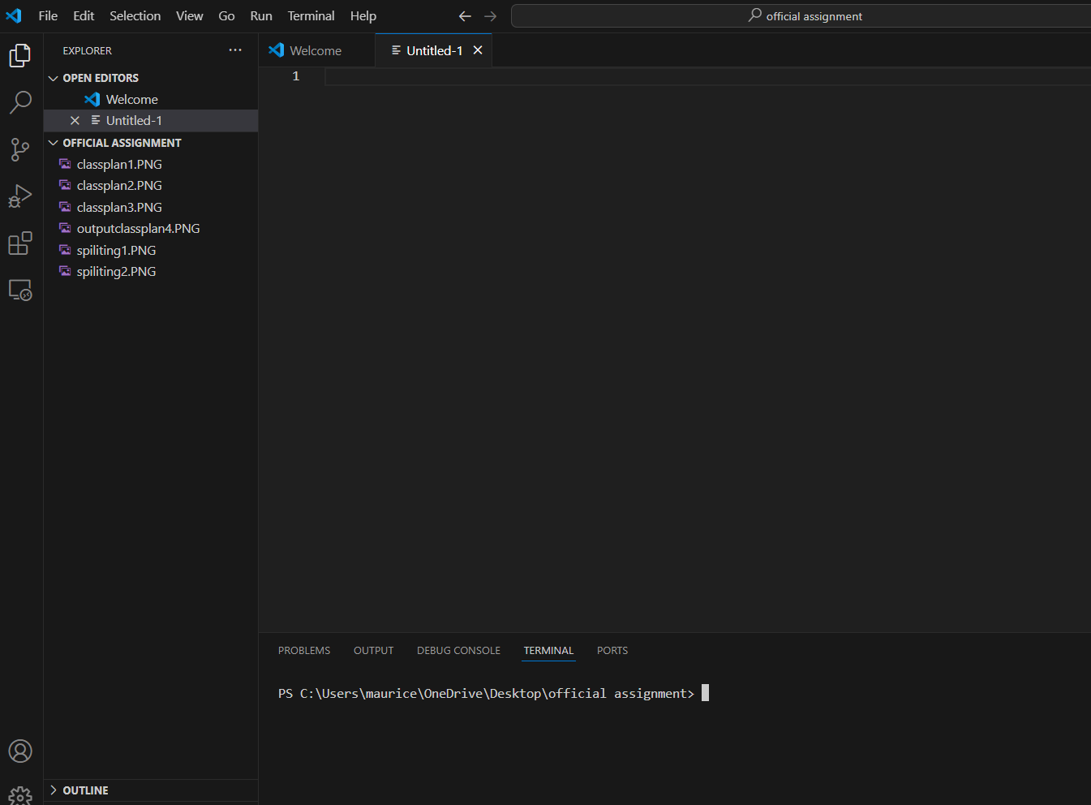

**Discuss the role of extensions in VS Code. How can users find, install, and manage extensions? Provide examples of essential extensions for web development.**

### **Role of Extensions in VS Code:**

1. **Enhanced Functionality**: Extensions add features such as language support (e.g., syntax highlighting, IntelliSense), debugging capabilities, code formatting, and integration with version control systems.
2. **Customization**: Users can personalize their editor with themes, icons, and productivity tools that suit their workflow and coding style.
3. **Integration with External Services**: Extensions can connect VS Code to external services like cloud platforms, databases, and deployment tools, facilitating seamless development and deployment processes.

### **Finding, Installing, and Managing Extensions:**

#### **Finding Extensions:**

* **Marketplace**: Visit the VS Code Marketplace at [marketplace.visualstudio.com/vscode](https://marketplace.visualstudio.com/vscode) or access it directly from within VS Code via the Extensions view (Ctrl+Shift+X).
* **Search**: Use keywords related to your development needs (e.g., "Python", "React", "Git") to find relevant extensions.

#### **Installing Extensions:**

* **From Marketplace**: Click on an extension, then click "Install".
* **Using Command Palette**: Open the Command Palette (Ctrl+Shift+P) and type "Extensions: Install Extensions", then search and install directly.

#### **Managing Extensions:**

* **Enabling/Disabling**: Toggle extensions on/off from the Extensions view to manage active ones.
* **Updating**: VS Code notifies you when updates are available; click "Update" in the Extensions view.
* **Settings**: Some extensions have configurable settings accessible from the Settings UI (Ctrl+,) or directly through JSON settings files.

### **Examples of Essential Extensions for Web Development:**

1. **ESLint**: Provides real-time linting for JavaScript and TypeScript, helping maintain code quality and adherence to coding standards.
2. **Prettier - Code Formatter**: Automatically formats code to ensure consistent style across your project, supporting various languages.
3. **Live Server**: Launches a local development server with live reload capability, useful for testing and debugging web applications.
4. **Debugger for Chrome**: Enables debugging JavaScript and TypeScript in Google Chrome directly from VS Code, with breakpoints and step-through debugging.
5. **HTML CSS Support**: Provides IntelliSense for HTML and CSS, enhancing productivity with auto-completion and navigation features.
6. **GitLens**: Supercharges the Git capabilities of VS Code, providing inline Git blame annotations, repository/file history navigation, and more.
7. **React/Redux snippets**: Offers code snippets for React components and Redux, speeding up development with predefined templates.

### **Benefits of Using Extensions:**

* **Productivity**: Automate repetitive tasks and streamline workflows.
* **Flexibility**: Customize VS Code to fit specific project requirements and coding preferences.
* **Community Support**: Access a vast ecosystem of extensions contributed by developers worldwide, ensuring up-to-date tools and enhancements.

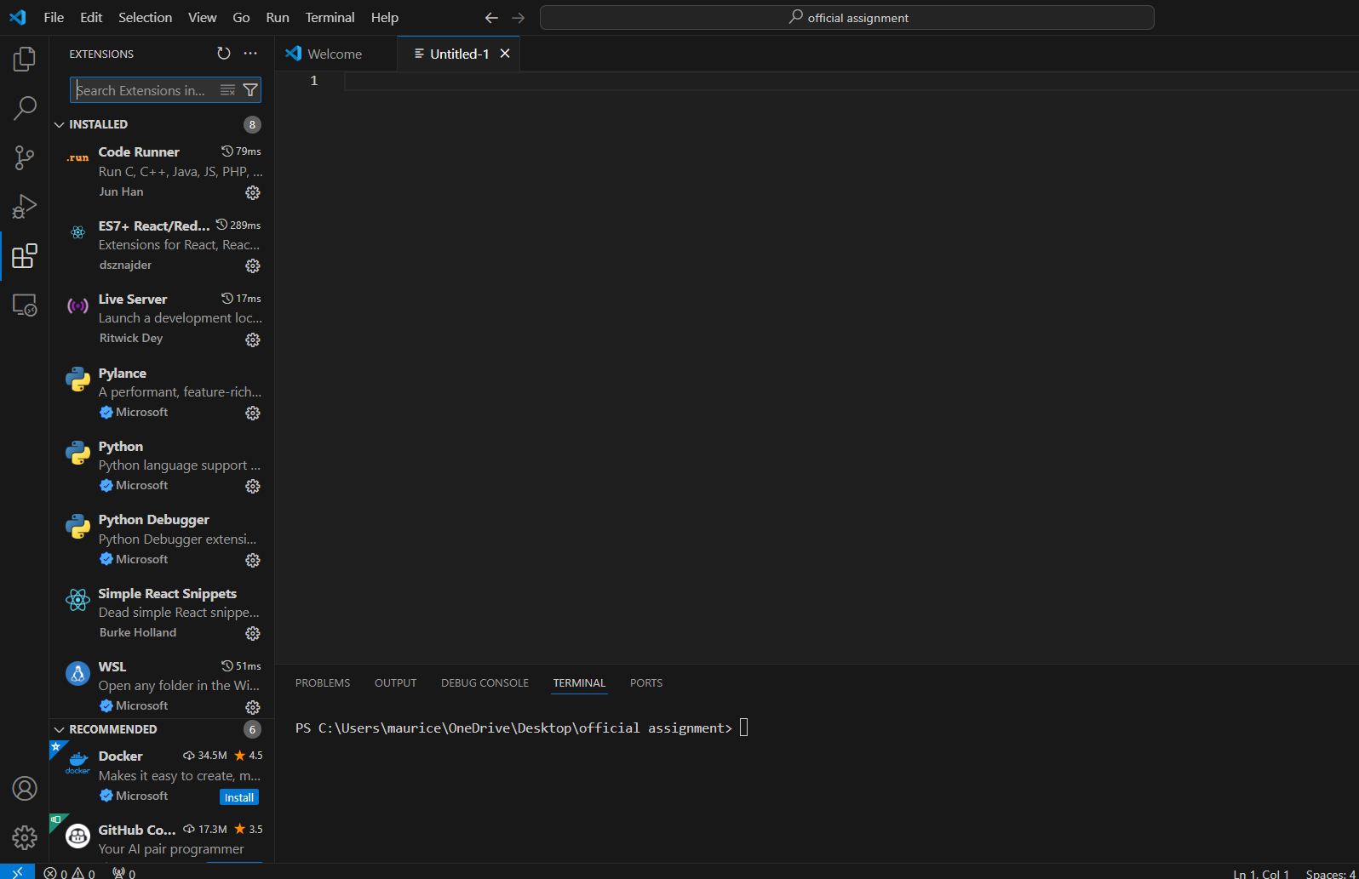

**Describe how to open and use the integrated terminal in VS Code. What are the advantages of using the integrated terminal compared to an external terminal?**

Opening and using the integrated terminal in Visual Studio Code (VS Code) is straightforward and offers several advantages over using an external terminal:

### **Opening the Integrated Terminal:**

1. **Accessing the Terminal:**
   * Open VS Code.
   * Go to the menu bar and click on Terminal > New Terminal, or use the shortcut Ctrl+ ` (backtick) to open a new terminal panel at the bottom of the editor.
2. **Switching Terminal Shells:**
   * By default, the integrated terminal uses the shell configured in your VS Code settings (e.g., PowerShell, Command Prompt on Windows, Bash on macOS/Linux).
   * You can change the default shell by selecting another option from the drop-down list at the top right corner of the terminal panel.

### **Using the Integrated Terminal:**

1. **Navigating Directories:**
   * Use standard shell commands (cd, ls on macOS/Linux or dir on Windows) to navigate directories.
   * Clicking on file paths in the terminal output opens the corresponding file in the editor.
2. **Running Commands:**
   * Execute commands directly in the terminal, such as running scripts (npm start), compiling code (gcc filename.c -o output), or managing version control (git commands).
3. **Output and Debugging:**
   * See command output directly within VS Code, allowing for quick reference while coding.
   * Debugging output and errors from tools like compilers or linters are conveniently displayed alongside the code editor.
4. **Integration with Tasks:**
   * Integrate terminal commands with VS Code tasks, automating build processes or running scripts (tasks.json configuration).
5. **Persistent Session:**
   * The integrated terminal maintains session state across VS Code sessions, including command history and directory state.

### **Advantages of Using the Integrated Terminal:**

1. **Seamless Integration:**
   * Operate within the same VS Code window, avoiding context switching between the editor and external terminals.
2. **Enhanced Productivity:**
   * Quickly access terminal commands and output while coding, improving workflow efficiency.
3. **Contextual Awareness:**
   * Terminal output and errors are linked to specific files and tasks in the editor, aiding in debugging and problem-solving.
4. **Customization and Settings:**
   * Configure shell preferences and terminal appearance directly within VS Code settings.
5. **Accessibility:**
   * Access the terminal from any project or workspace without launching an external application, maintaining a streamlined development environment.

Using the integrated terminal in VS Code enhances developer productivity by providing a seamless workflow for coding, debugging, and project management tasks, all within a unified development environment.

**Explain how to create, open, and manage files and folders in VS Code. How can users navigate between different files and directories efficiently?**

### **Creating and Opening Files and Folders:**

1. **Creating a New File or Folder:**
   * **File**: Right-click in the Explorer view (Side Bar) or use the Command Palette (Ctrl+Shift+P) and type "New File" to create a new file.
   * **Folder**: Similarly, right-click and select "New Folder" in the Explorer view to create a new directory.
2. **Opening Files:**
   * Double-click on a file in the Explorer view to open it in the editor.
   * Use the Command Palette (Ctrl+Shift+P) and type "File: Open File" to navigate to and open a specific file.
3. **Opening Multiple Files:**
   * Hold down Ctrl (Windows/Linux) or Cmd (Mac) and click on multiple files in the Explorer view to open them simultaneously.
   * Use the Command Palette (Ctrl+Shift+P) and type "File: Open Folder" to open an entire folder in VS Code.

### **Managing Files and Folders:**

1. **Renaming and Deleting:**
   * Right-click on a file or folder in the Explorer view and select "Rename" or "Delete" to modify or remove items.
2. **Moving and Copying:**
   * Drag and drop files or folders within the Explorer view to move them.
   * Copy files or folders using standard operating system commands (Ctrl+C, Ctrl+V on Windows/Linux or Cmd+C, Cmd+V on Mac).
3. **Saving Files:**
   * Files are automatically saved in VS Code. Use Ctrl+S (Windows/Linux) or Cmd+S (Mac) to manually save changes.

### **Efficient Navigation Between Files and Directories:**

1. **Using Keyboard Shortcuts:**
   * Ctrl+P (Windows/Linux) or Cmd+P (Mac): Open the Quick Open dialog to quickly navigate to files by name.
   * Ctrl+Tab (Windows/Linux) or Cmd+Tab (Mac): Cycle through open editor tabs.
   * Ctrl+\`` (Windows/Linux) or Cmd+`` (Mac): Toggle the integrated terminal to execute commands or navigate directories.
2. **Explorer View (Side Bar):**
   * Collapse or expand directories in the Explorer view to focus on specific parts of your project.
   * Pin frequently accessed files or folders to keep them easily accessible.
3. **Go to Definition:**
   * Right-click on a symbol or variable and select "Go to Definition" (F12) to jump directly to its definition within your codebase.
4. **Search Across Files:**
   * Use Ctrl+Shift+F (Windows/Linux) or Cmd+Shift+F (Mac) to perform a global search across all files in your workspace.
5. **File Navigation Extensions:**
   * Install extensions like "Project Manager" or "Bookmarks" to save and quickly access specific project files or locations.

By leveraging these tools and techniques, users can efficiently create, open, manage, and navigate between files and folders in Visual Studio Code, optimizing their workflow and enhancing productivity during development tasks.

**Where can users find and customize settings in VS Code? Provide examples of how to change the theme, font size, and keybindings.**

### **Accessing Settings:**

1. **Using the Settings UI:**
   * Click on the gear icon (⚙️) in the lower-left corner of the VS Code window, or press Ctrl+, (Windows/Linux) or Cmd+, (Mac) to open the Settings UI.
2. **Editing JSON Settings:**
   * Click on the {} icon in the upper-right corner of the Settings UI to open the settings.json file for direct JSON editing.

### **Examples of Customizations:**

#### **1. Changing the Theme:**

1. **Using the Settings UI:**
   * In the Search bar of the Settings UI, type "Color Theme".
   * Click on "Color Theme" under "Workbench" to browse available themes.
   * Click on a theme to apply it instantly.
2. **Editing JSON Settings:**
   * Open settings.json.
   * Add or modify "workbench.colorTheme": "Theme Name" to change the color theme.

#### **2. Adjusting Font Size:**

1. **Using the Settings UI:**
   * In the Search bar of the Settings UI, type "Font Size".
   * Adjust the "Editor: Font Size" setting to the desired value (e.g., 14).
2. **Editing JSON Settings:**
   * Open settings.json.
   * Add or modify "editor.fontSize": 14 (replace 14 with your preferred font size).

#### **3. Customizing Keybindings:**

1. **Using the Settings UI:**
   * In the Search bar of the Settings UI, type "Keybindings".
   * Click on "Keybindings" to view and customize keyboard shortcuts.
   * Click on the pencil icon next to a command to change its keybinding.
2. **Editing JSON Settings:**
   * Open keybindings.json by clicking on "Open Keyboard Shortcuts" in the Settings UI.
   * Add custom keybindings using JSON format, such as:

json

Copy code

[  
 {  
 "key": "ctrl+shift+l",  
 "command": "editor.action.insertLineAfter",  
 "when": "editorTextFocus"  
 }  
]

* + Save the file to apply the changes.

### **Additional Tips:**

* **Search and Filters**: Use the Search bar in the Settings UI to quickly find specific settings or configurations.
* **Extensions**: Some extensions may contribute additional settings that can be customized through the same Settings UI or JSON files.

By utilizing these methods, users can easily customize their VS Code environment to suit their preferences, enhancing productivity and comfort during coding sessions.

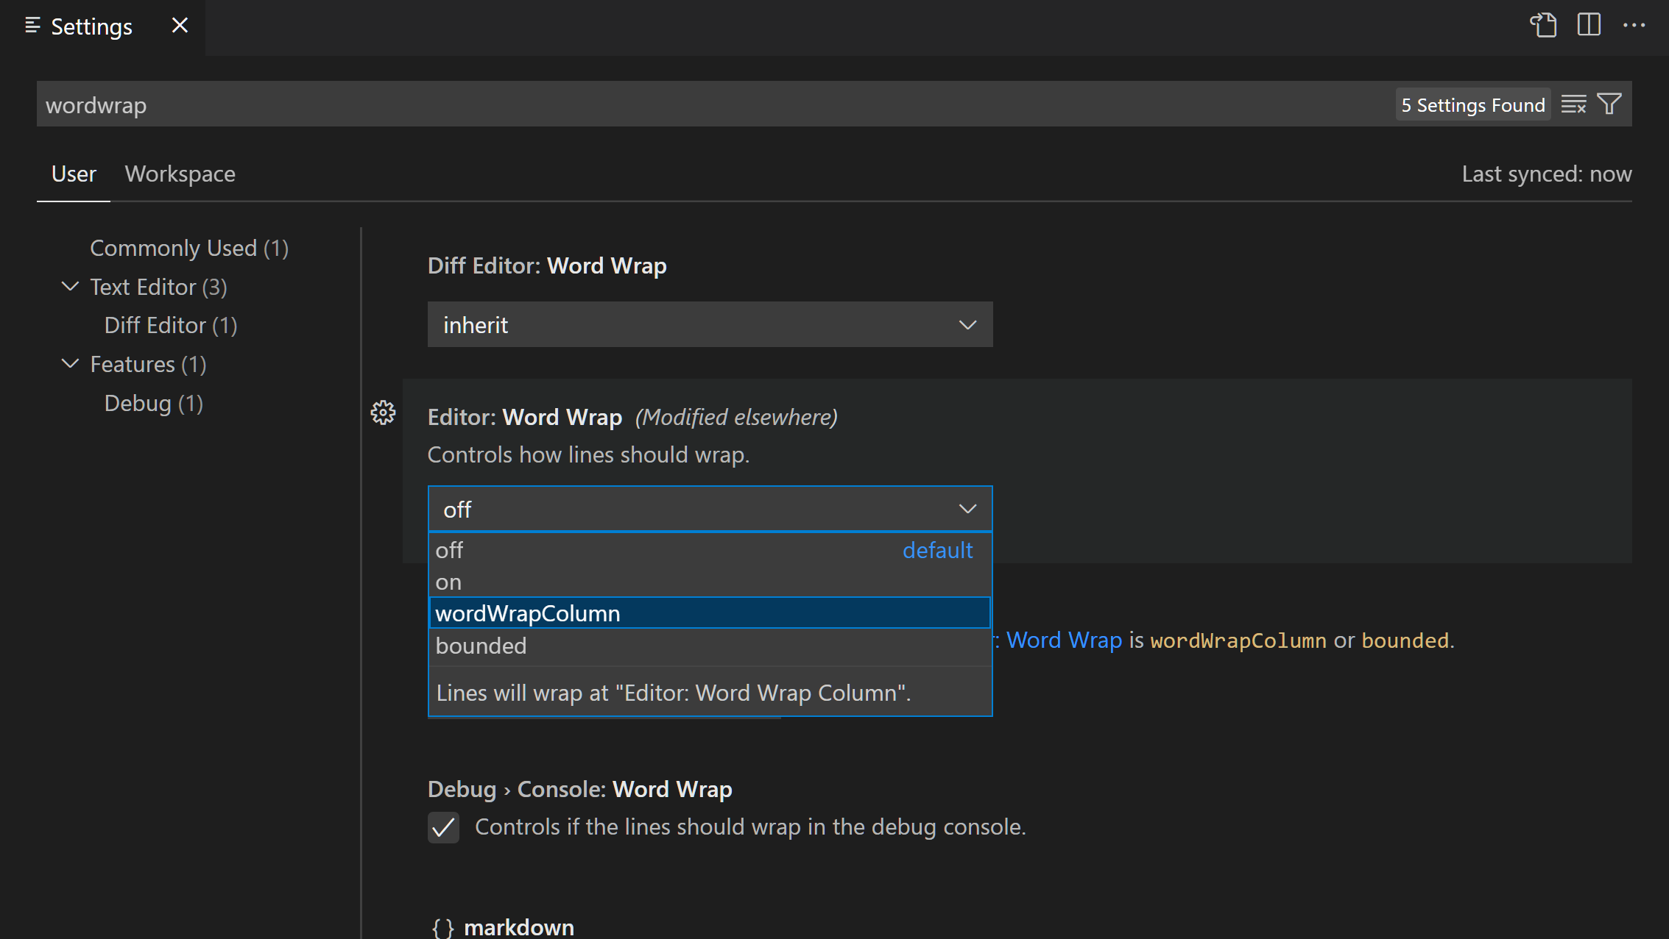

**Outline the steps to set up and start debugging a simple program in VS Code. What are some key debugging features available in VS Code?**

### **Steps to Set Up and Start Debugging:**

1. **Install Required Extensions (if applicable):**
   * Ensure you have the necessary language-specific extensions installed for debugging (e.g., Python, JavaScript).
2. **Open Your Project:**
   * Open your project folder in VS Code (File > Open Folder...).
3. **Create or Review Launch Configuration:**
   * Navigate to the Debug view (Ctrl+Shift+D) in the Side Bar.
   * Click on the gear icon (⚙️) to open the launch.json file.
   * Add a configuration for your program if it doesn't exist, specifying the program's entry point and any required parameters.
4. **Set Breakpoints:**
   * Open the file containing the code you want to debug.
   * Click in the left margin next to the line number to set a breakpoint. This marks where execution should pause for inspection.
5. **Start Debugging:**
   * Press F5 or click on the green play button (▶️) in the Debug view to start debugging. VS Code will launch the program in debug mode.
6. **Debugging Session:**
   * Execution will pause at the first breakpoint encountered.
   * Use debugging controls such as step over (F10), step into (F11), and step out (Shift+F11) to navigate through code execution.
7. **Inspect Variables and State:**
   * View variable values in the Variables view (Ctrl+Shift+D) or hover over variables in the editor to see their current values.
   * Use the Watch view to monitor specific variables or expressions.
8. **Continue Execution and Finish Debugging:**
   * Continue execution (F5) after resolving issues or understanding the program flow.
   * Stop debugging (Shift+F5) to terminate the debugging session.

### **Key Debugging Features in VS Code:**

* **Breakpoints**: Set breakpoints to pause execution at specific lines for inspection.
* **Variable Watch**: Monitor variable values and expressions in real-time during debugging.
* **Call Stack**: View the call stack to understand the hierarchy of function calls leading to the current point of execution.
* **Debug Console**: Interact with the program via the debug console to execute commands or evaluate expressions.
* **Conditional Breakpoints**: Set breakpoints that only trigger based on specified conditions.
* **Multi-threaded Debugging**: Debug applications with multi-threaded execution, monitoring each thread separately.
* **Remote Debugging**: Debug applications running on remote servers or devices, connecting via SSH or other protocols.
* **Integrated Terminal**: Access an integrated terminal to execute commands or view logs during debugging.

By leveraging these debugging features, developers can efficiently diagnose and resolve issues in their code, ensuring smoother development and better code quality in Visual Studio Code

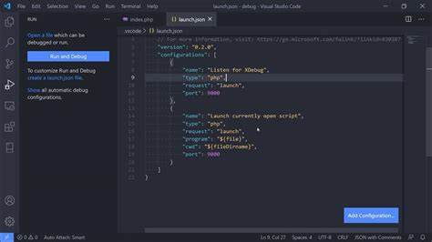

**How can users integrate Git with VS Code for version control? Describe the process of initializing a repository, making commits, and pushing changes to GitHub.**

### **Initializing a Repository:**

1. **Open VS Code:**
   * Open your project folder in VS Code (File > Open Folder...).
2. **Initialize Git Repository:**
   * Open the Source Control view by clicking on the Git icon in the Activity Bar (Ctrl+Shift+G).
   * Click on "Initialize Repository" or use the Command Palette (Ctrl+Shift+P) and type "Git: Initialize Repository".
3. **Select Repository Location:**
   * Choose the root folder of your project to initialize as a Git repository.
   * VS Code will create a .git folder in your project directory to manage version control.

### **Making Commits:**

1. **Stage Changes:**
   * In the Source Control view, you'll see a list of changed files.
   * Click on the + icon next to each file or use the checkboxes to stage files for the next commit.
2. **Write Commit Message:**
   * Enter a meaningful commit message in the text box at the top of the Source Control view, describing the changes made in this commit.
3. **Commit Changes:**
   * Click on the checkmark icon (✓) or use the Command Palette (Ctrl+Shift+P) and type "Git: Commit" to commit the staged changes.
   * Optionally, use Ctrl+Enter to commit directly from the commit message box.

### **Pushing Changes to GitHub:**

1. **Link VS Code with GitHub:**
   * Ensure you have set up SSH keys or have GitHub credentials configured in VS Code for authentication.
   * If not configured, you may be prompted to sign in to GitHub when pushing changes.
2. **Push Changes:**
   * After committing changes, click on the three dots (...) next to the commit message in the Source Control view.
   * Select "Push" to push the committed changes to the remote repository (GitHub).
3. **Enter Credentials (if needed):**
   * If authentication is required, VS Code will prompt you to enter your GitHub username and password or token.
4. **Monitor Progress:**
   * Monitor the progress of the push operation in the bottom-left corner of the VS Code window.

### **Additional Git Operations in VS Code:**

* **Pull Changes**: Fetch and integrate changes from the remote repository (Git: Pull).
* **Branch Management**: Create, switch, merge, and delete branches (Git: Create Branch, Git: Switch Branch, Git: Merge Branch, Git: Delete Branch).
* **Resolve Conflicts**: Handle merge conflicts directly within VS Code.
* **View History**: Review commit history (Git: View History) and compare changes between commits.

By following these steps, users can effectively integrate Git with VS Code for version control, making it easier to manage project history, collaborate with team members, and synchronize changes with remote repositories like GitHub.

